EE / CprE / SE 492 Weekly Report

October 3 - October 17, 2024

sddec24-16

Designing a Smart Plant Nurturing System Enabled by IoT Technology

Faculty Advisor / Client: Md Maruf Ahamed

**Team Members:**

* Tejal Devshetwar - Frontend
* Holden Brown - Frontend/backend
* Blake Hardy - Backend
* Cameron Jones - Backend
* Cayden Kelley - Hardware
* Chase O’Connell - Hardware

**Summary of Work:**

Within the past 2 weeks, we were able to get past one of our major roadblocks in setting up the hardware. By using an Arduino with Modbus libraries, we were finally able to obtain data from our NPK sensor. For this reason, we decided that we should change our microcontroller to an Arduino to save development time. We also were able to verify that our NPK sensor is still functional by using a device that is meant for displaying NPK data. In terms of hardware testing, we were able to start calibrating our watering system by having one of the pumps controlled by the moisture sensor data. Within the next few weeks, we plan to work on ordering final sensors to use, integrating the Arduino with our existing setup, and continuing calibration of the device. We also have recognized the need for a PCB to handle the device power requirements as soon as possible so we can continuously receive data for testing.

**Work Period Accomplishments:**

* Borrowed microcontroller from ETG, officially gave up on the pico and moving to an arduino mkr 1010 wifi.
* Got modbus working with arduino FINALLY
* Began looking into enclosure requirements for size and fittings
* Ordered new microcontroller, will order additional sensors
* Made a few requirements changes regarding real time remote control, will probably abandon that and go fully autonomous. Potentially can use bluetooth for direct communication with the mobile app but viability is TBD
* Wheat grass for testing was planted, not sure how well it will grow in the senior design lab.
* Considering a couple of extra features like motor shunts for measuring motor current, also TBD
* Did some initial tests on the watering system using moisture data

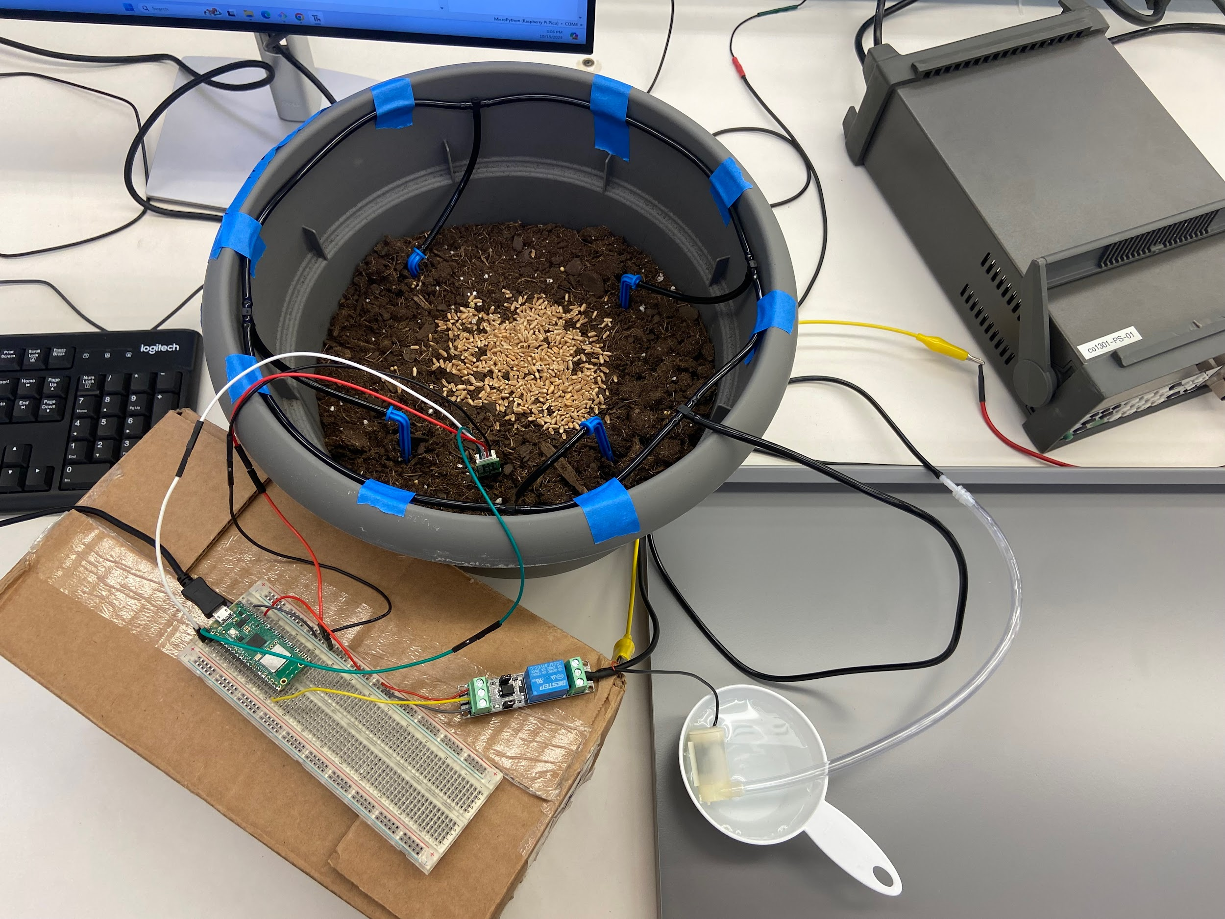

Figure 1: Watering Test Setup with Wheatgrass

**Plans for Coming Week + Action Items:**

* Holden Brown - get round trip software up and working.
* Tejal Devshetwar - Get started with looking at how to set up the websocket communication. Find other alternative methods as well to connect which might be easier to implement in comparison to websockets.
* Blake Hardy - pick up new microcontroller, get wireless coms and look into low power modes but that isn’t super high priority. Might see if I can help with the power and board layout. Might need holden’s help with coms.
* Cameron Jones - Work on getting full loop working. Perform research on websockets to see if they can still work, maybe see about using pico as a websocket slave.
* Cayden Kelley - Focus on PCB development for power so data can be collected consistently. Work with Chase to determine which final 2 sensors to buy (NPK including moisture, PAR light sensor) Also, order additional relay(s). Set up my own moisture and watering system for additional data collection opportunities.
* Chase O’Connell - Focus on PCB development for power so data can be collected consistently. Work with Cayden to determine which final 2 sensors to buy (NPK including moisture, PAR light sensor) Also order additional relay(s).

**Pending Issues:**

* Tejal Devshetwar
  + No issues
* Holden Brown
  + No issues
* Blake Hardy
  + No issues
* Cameron Jones
  + Still having difficulty working with university wifi.
* Cayden Kelley
  + No issues
* Chase O’Connell
  + Issue of a consistent power supply in order to collect data, really just need to get started on the PCB so we can have consistent data collection.

**Individual Contributions:**

| Team Member | Contribution | Weekly Hours | Total Hours |
| --- | --- | --- | --- |
| Tejal Devshetwar | I did not contribute to anything this week as I was in Philadelphia. | 0 | 27 |
| Holden Brown | Got the app up and running again and working on round trip. Fixed dependency errors. | 1.5 | 51 .9 |
| Blake Hardy | Looked into a couple libraries for low power and wireless communication. Waiting on microcontroller to ship before work can begin | 2 | 46 |
| Cameron Jones | Worked with Blake to get the modbus working with the pico. Switched to arduion. Planned enclosure. Researched related embedded concepts | 8 | 40.6 |
| Cayden Kelley | Worked with the NPK sensor to understand the type of data it returns, and the effects different soil types and moisture contents have on the reading. Also briefly worked with Blake and Cameron to get the NPK sensor working with the Arduino. Worked with Chase to set up watering system and initial calibration for when to water in relation to moisture sensor data. Was able to trigger pumps. | 5 | 58.6 |
| Chase O’Connell | Set up watering system and initial calibration for when to water in relation to moisture sensor data. Was able to trigger pumps. | 5.5 | 41 |